07th , Oct, 2026
Lab Assignment 01

ANN

Submitted By: Shafi Azam
Registration No: (SP24-BAI-047)
Submitted To: Sir Anayatullah
Subject: ANN And Deep Learning



Department of Computer Science
Comsats University Islamabad
Islamabad Campus

Lab Tasks
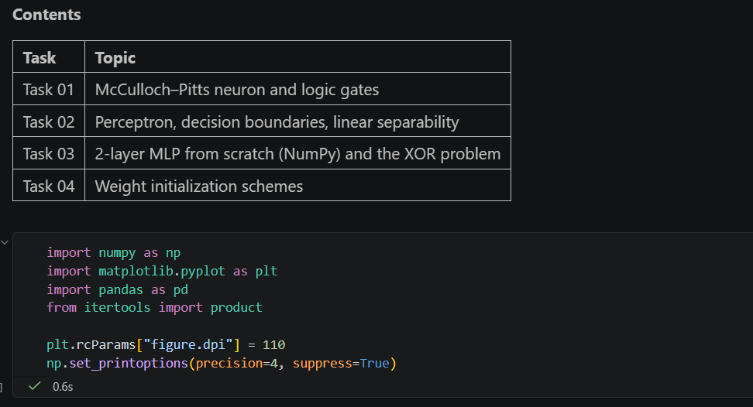
Task 01
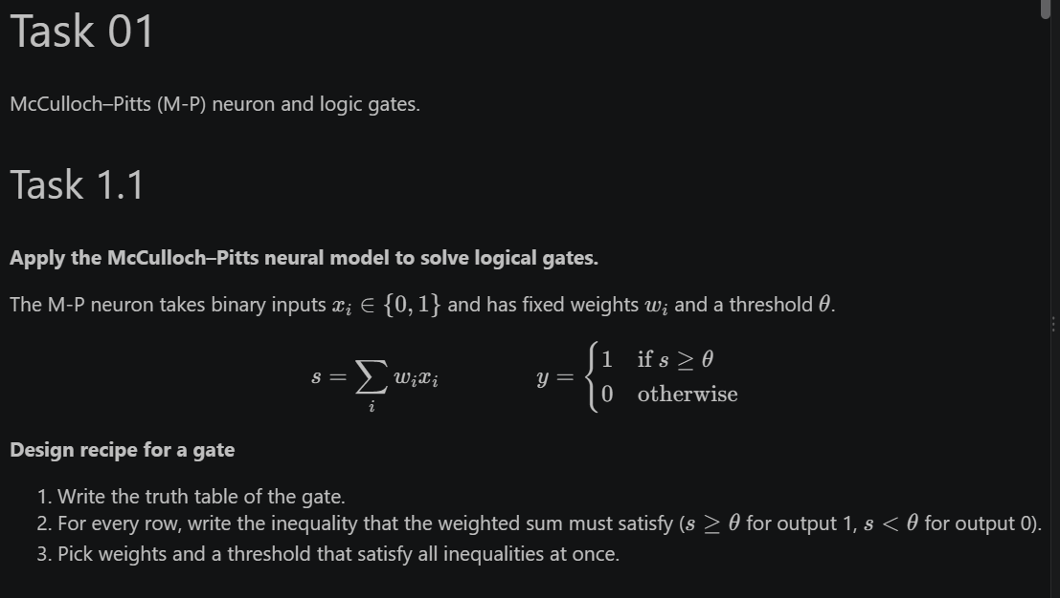
Task 1.1
Task 1.2
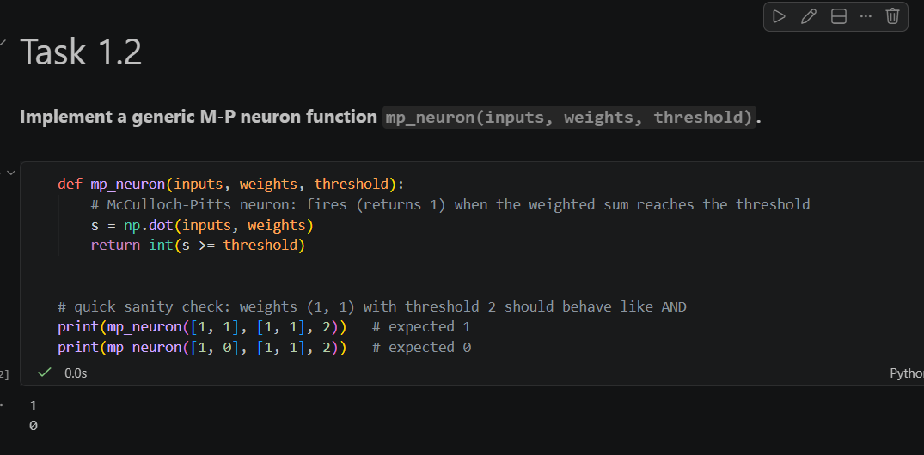

Task 1.3
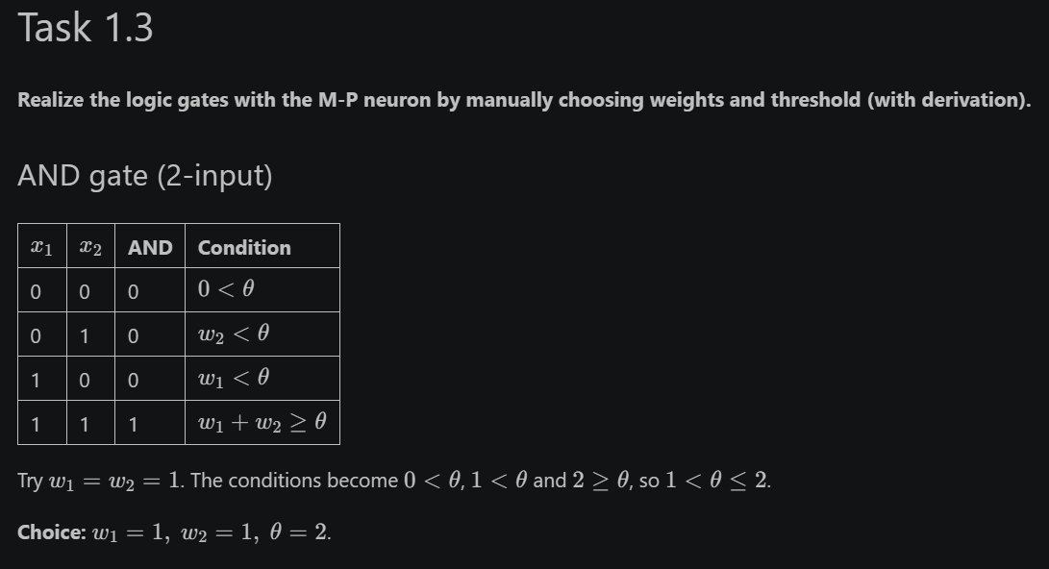
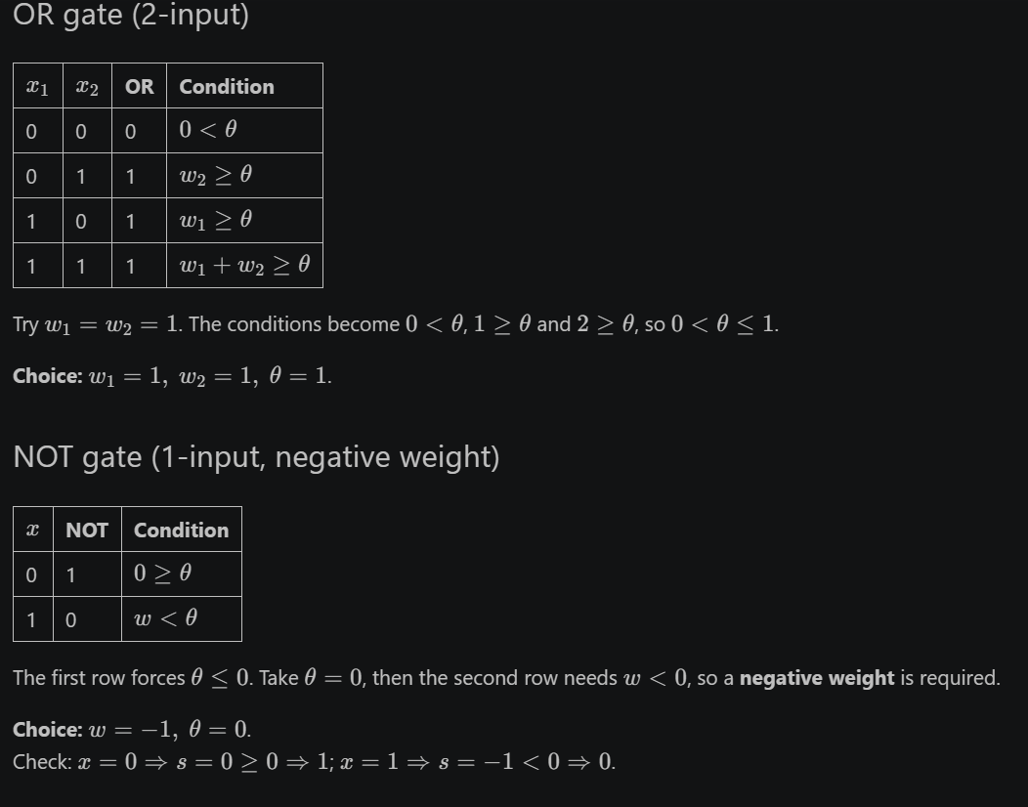
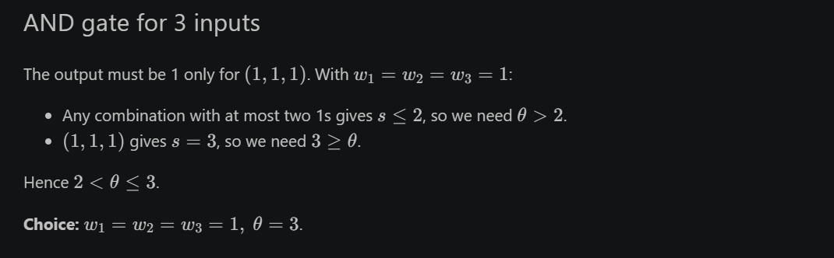
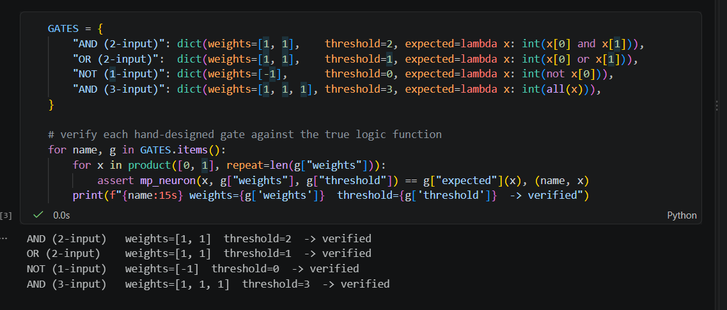

Task 1.4
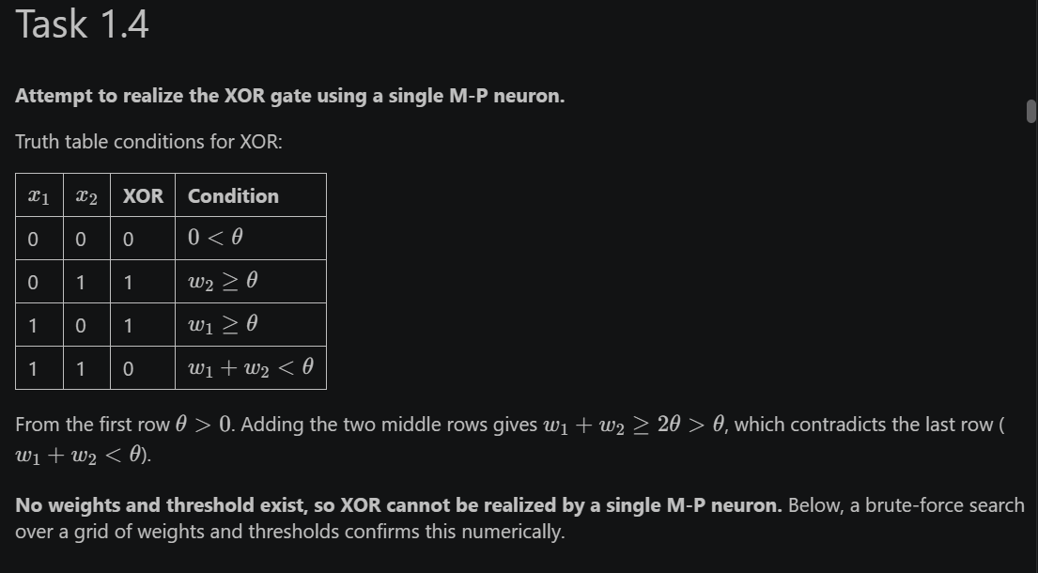
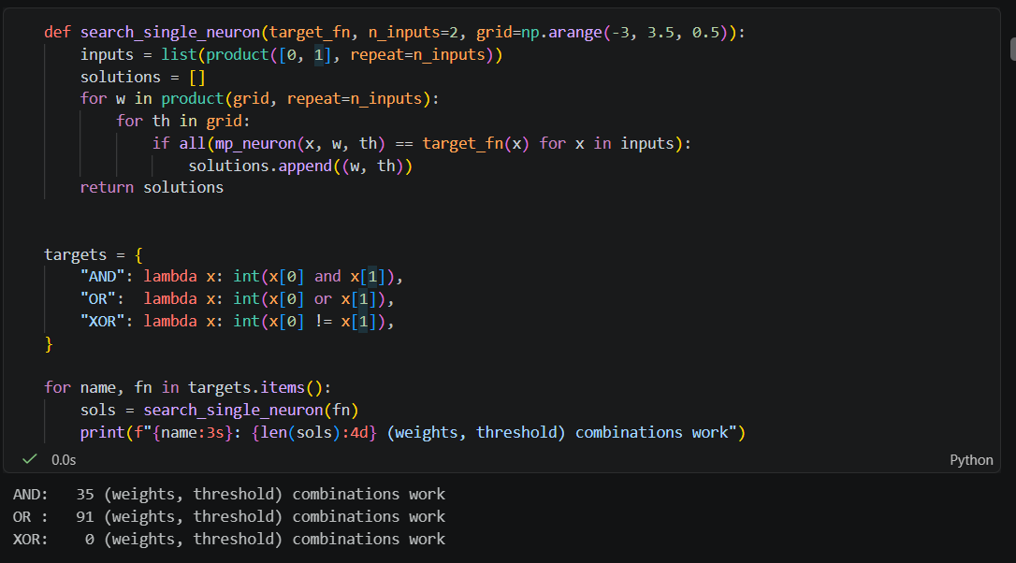
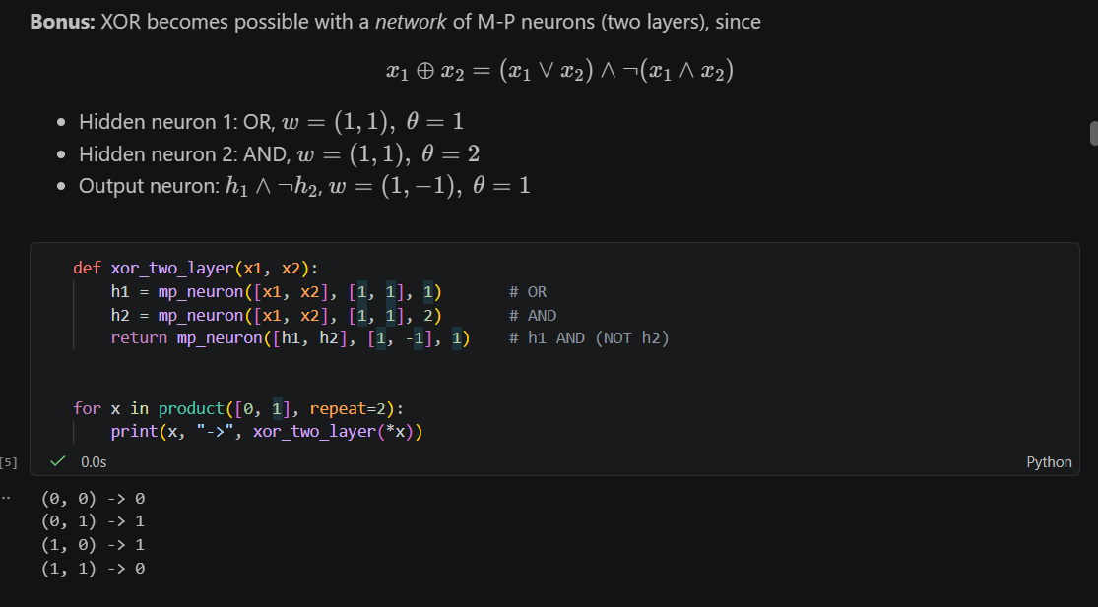

Task 1.5
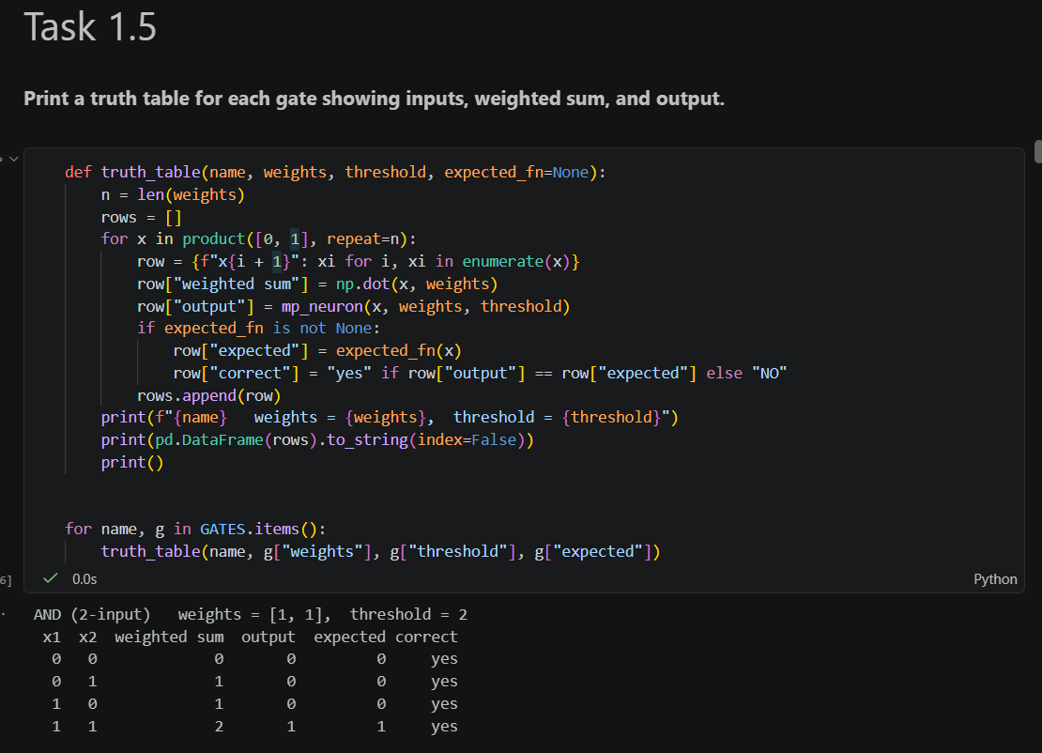
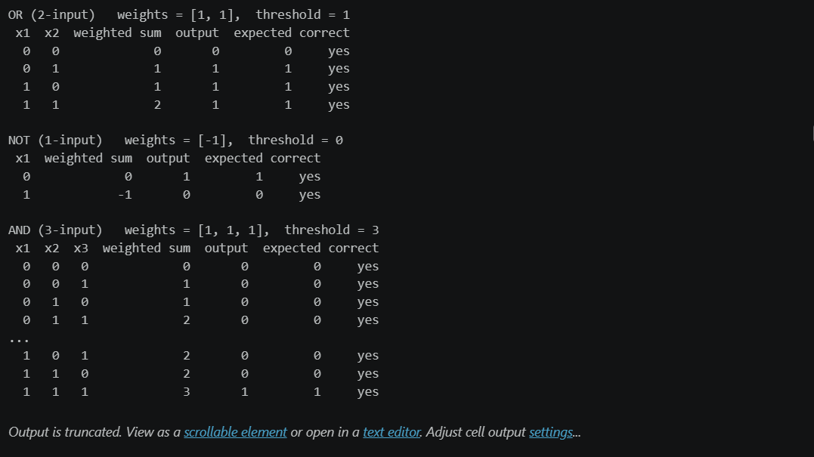
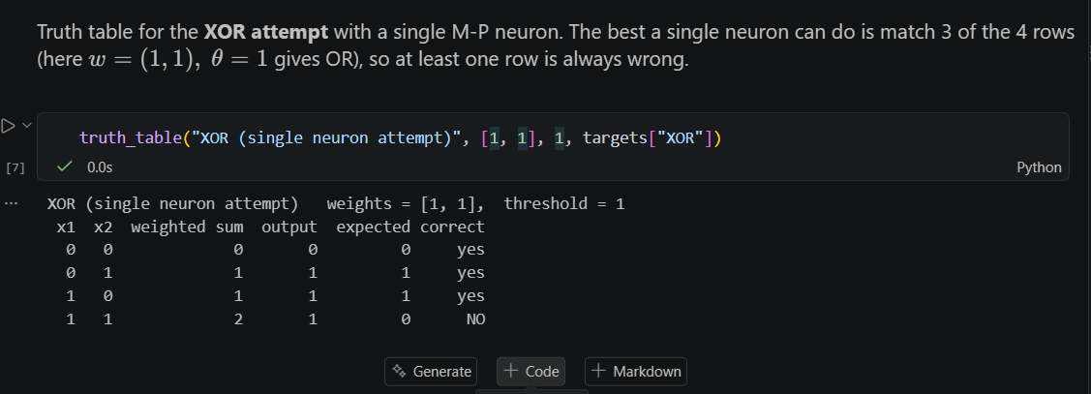

Task 02
Task 2.1
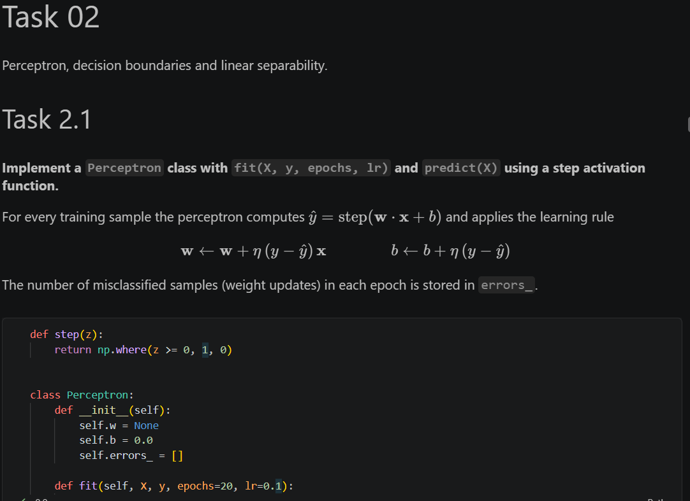

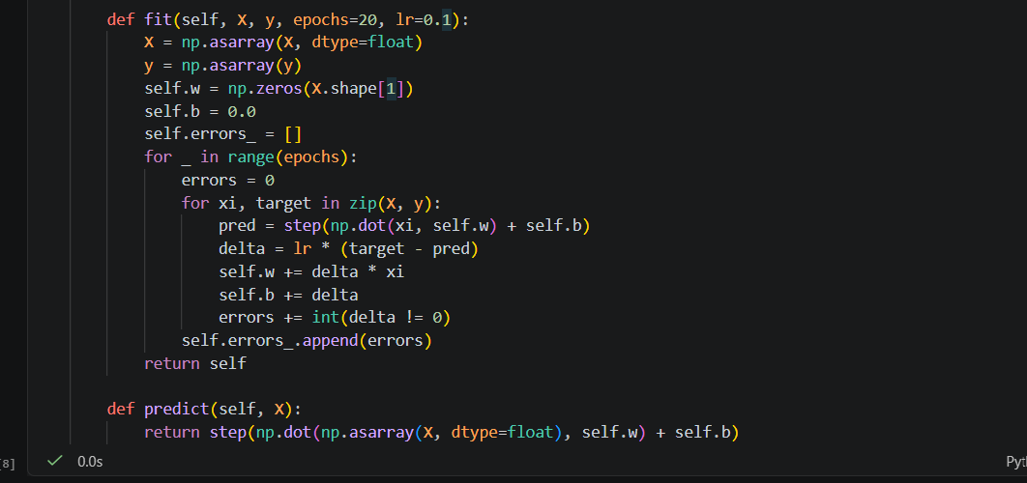

Task 2.2
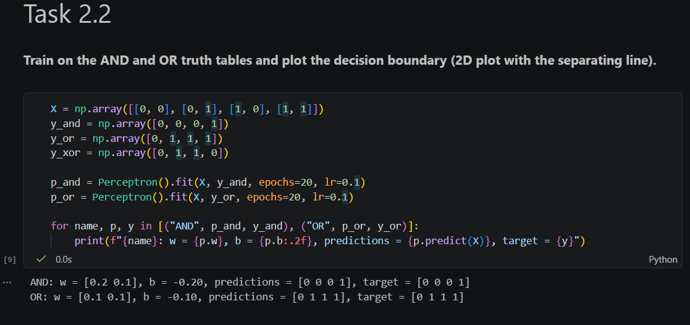

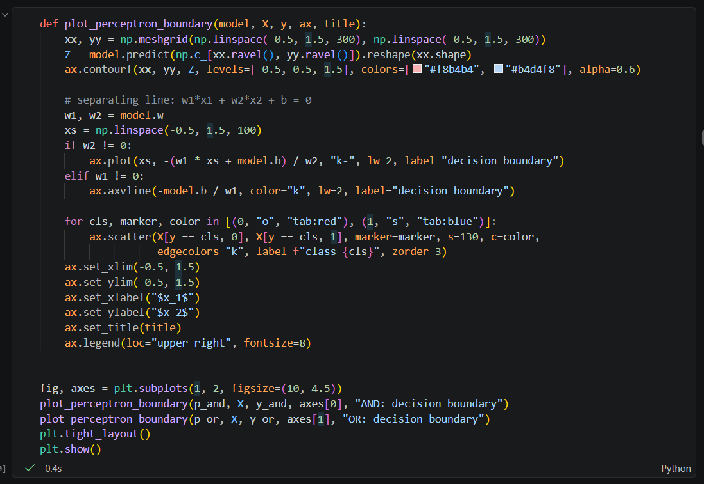
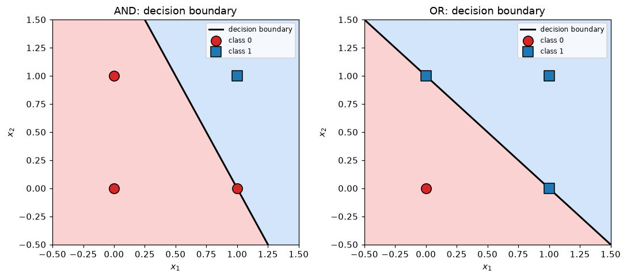

Task 2.3
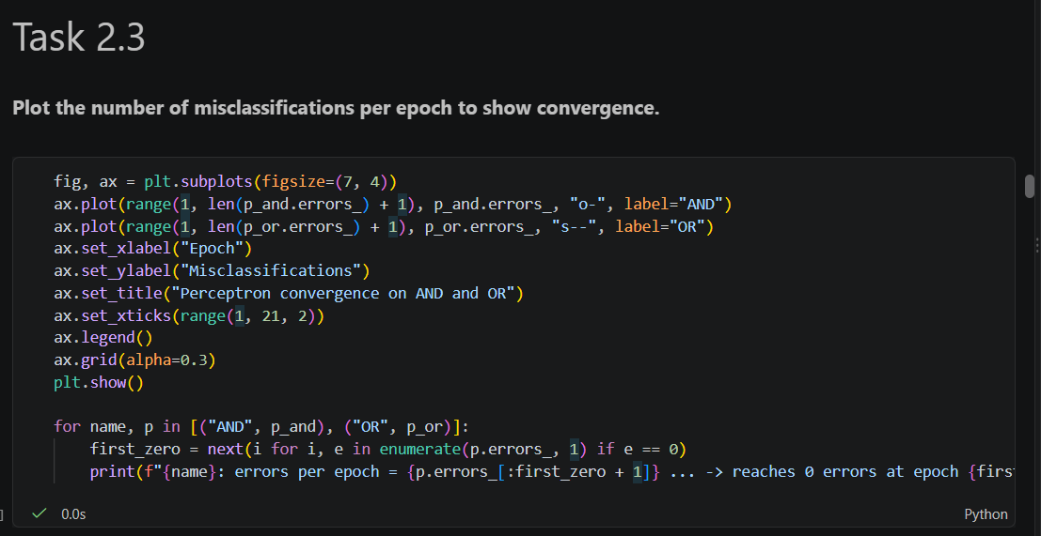
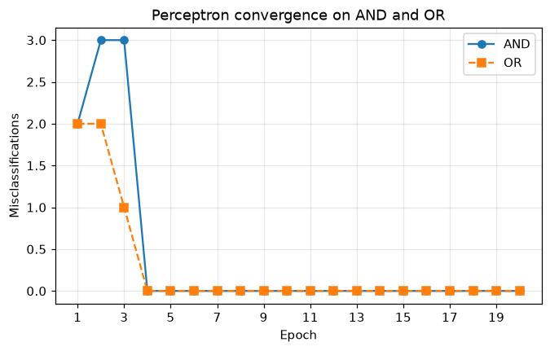

Task 2.4
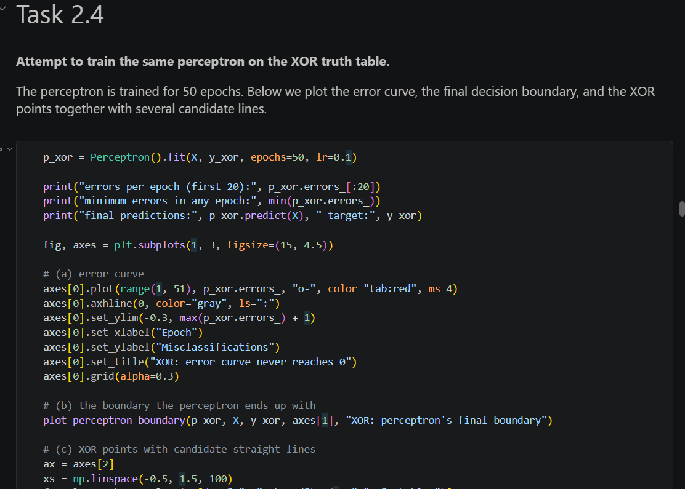
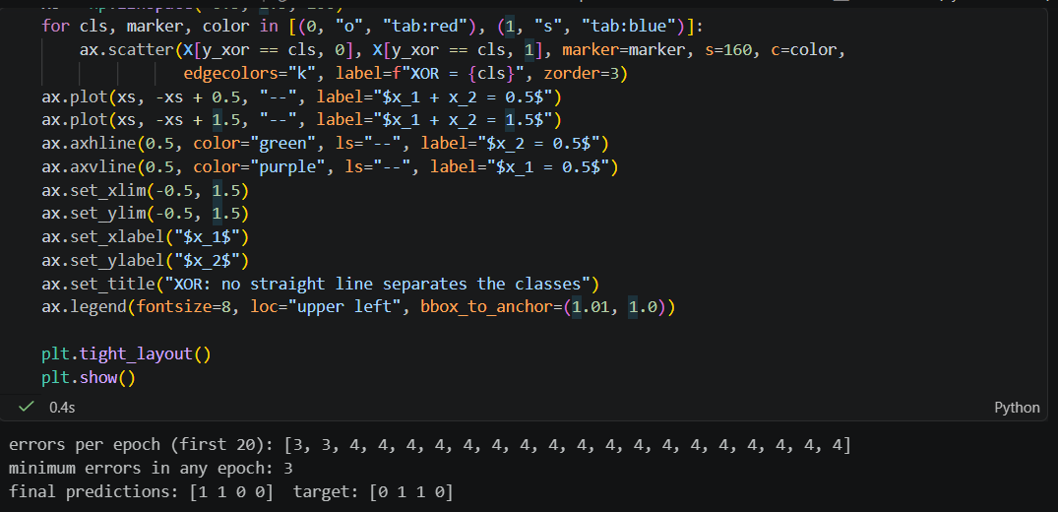

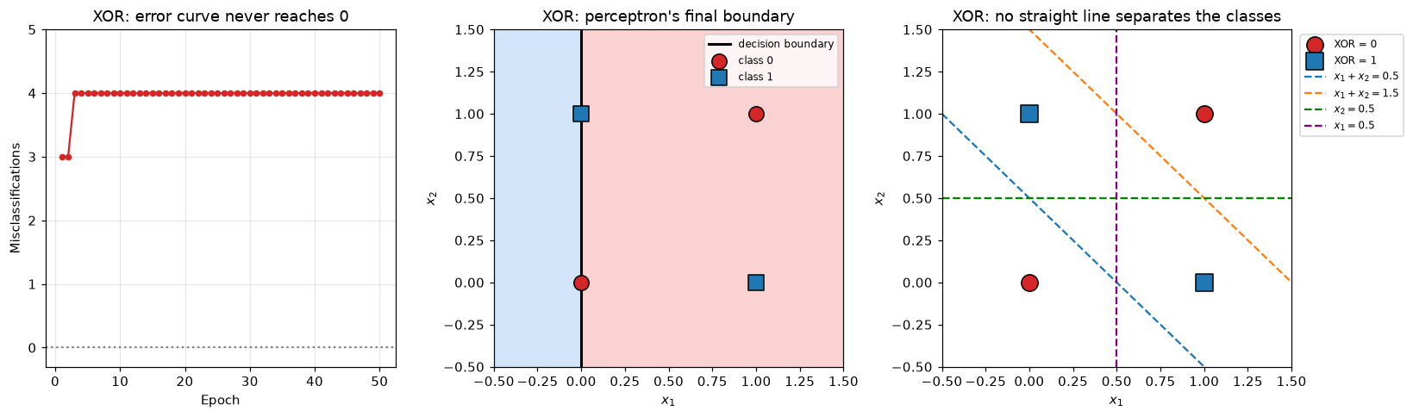
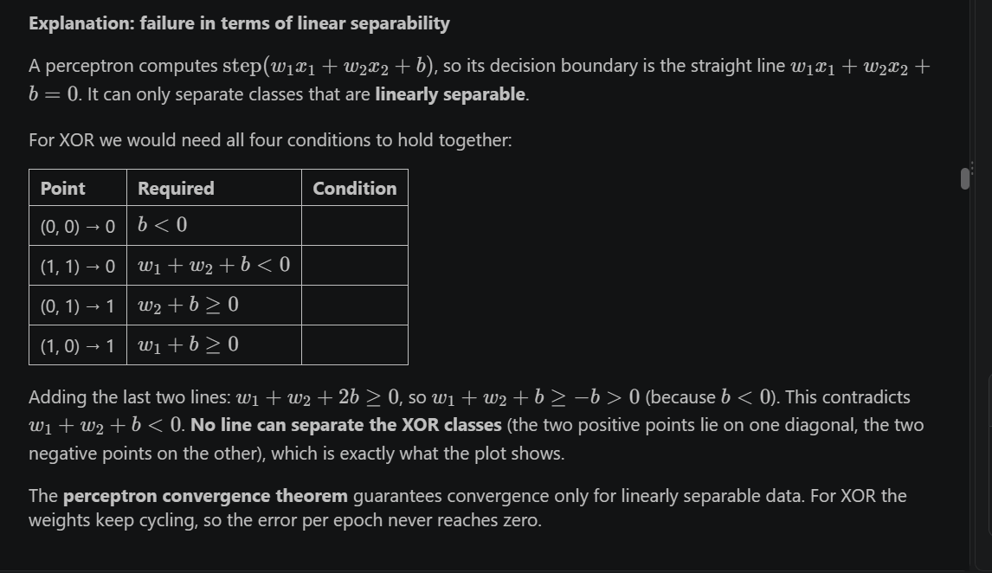

Task 03
Task 3.1
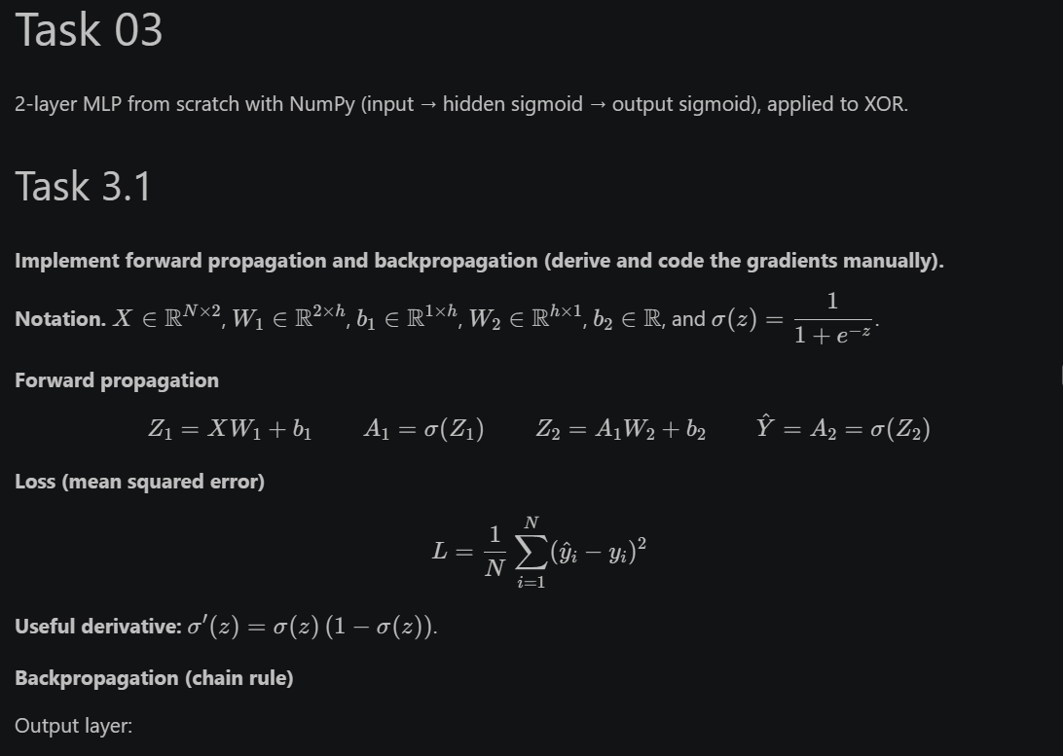
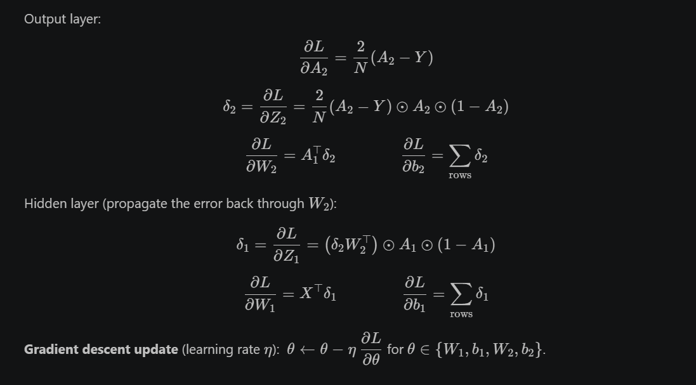
def sigmoid(z):
return 1.0 / (1.0 + np.exp(-np.clip(z, -500, 500)))

class MLP:
def __init__(self, n_in=2, n_hidden=2, n_out=1, lr=0.5, seed=0):
self.n_in, self.n_hidden, self.n_out = n_in, n_hidden, n_out
self.lr = lr
self.rng = np.random.default_rng(seed)
self._init_params()

def _init_params(self):
# plain random initialization, N(0, 1)
self.W1 = self.rng.standard_normal((self.n_in, self.n_hidden))
self.b1 = np.zeros((1, self.n_hidden))
self.W2 = self.rng.standard_normal((self.n_hidden, self.n_out))
self.b2 = np.zeros((1, self.n_out))

def forward(self, X):
self.X = X
self.Z1 = X @ self.W1 + self.b1
self.A1 = sigmoid(self.Z1)
self.Z2 = self.A1 @ self.W2 + self.b2
self.A2 = sigmoid(self.Z2)
return self.A2

def loss(self, Y):
return float(np.mean((self.A2 - Y) ** 2))

def backward(self, Y):
N = Y.shape[0]
dZ2 = (2.0 / N) * (self.A2 - Y) * self.A2 * (1 - self.A2)
dW2 = self.A1.T @ dZ2
db2 = dZ2.sum(axis=0, keepdims=True)
dZ1 = (dZ2 @ self.W2.T) * self.A1 * (1 - self.A1)
dW1 = self.X.T @ dZ1
db1 = dZ1.sum(axis=0, keepdims=True)
return dW1, db1, dW2, db2

def fit(self, X, Y, epochs=10000, tol=0.01, stop_early=False):
X = np.asarray(X, dtype=float)
Y = np.asarray(Y, dtype=float).reshape(-1, 1)
self.loss_history_ = []
self.converged_epoch_ = None # first epoch where loss < tol
for epoch in range(1, epochs + 1):
self.forward(X)
L = self.loss(Y)
self.loss_history_.append(L)
if L < tol and self.converged_epoch_ is None:
self.converged_epoch_ = epoch
if stop_early:
break
dW1, db1, dW2, db2 = self.backward(Y)
self.W1 -= self.lr * dW1
self.b1 -= self.lr * db1
self.W2 -= self.lr * dW2
self.b2 -= self.lr * db2
return self

def predict_proba(self, X):
return self.forward(np.asarray(X, dtype=float)).ravel()

def predict(self, X):
return (self.predict_proba(X) >= 0.5).astype(int)

def numerical_grad(model, X, Y, param, eps=1e-6):
grad = np.zeros_like(param)
for idx in np.ndindex(param.shape):
old = param[idx]
param[idx] = old + eps
model.forward(X)
loss_plus = model.loss(Y)
param[idx] = old - eps
model.forward(X)
loss_minus = model.loss(Y)
param[idx] = old
grad[idx] = (loss_plus - loss_minus) / (2 * eps)
return grad

Xc = np.array([[0, 0], [0, 1], [1, 0], [1, 1]], dtype=float)
Yc = np.array([0, 1, 1, 0], dtype=float).reshape(-1, 1)

check_model = MLP(n_hidden=3, seed=1)
check_model.forward(Xc)
analytic = check_model.backward(Yc)

for name, param, g in zip(["W1", "b1", "W2", "b2"],
[check_model.W1, check_model.b1, check_model.W2, check_model.b2],
analytic):
num = numerical_grad(check_model, Xc, Yc, param)
print(f"{name}: max |analytic - numerical| = {np.max(np.abs(g - num)):.2e}")

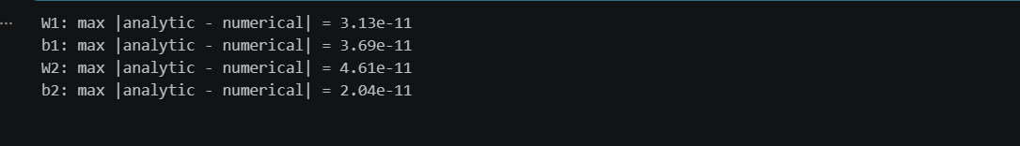
Task 3.2
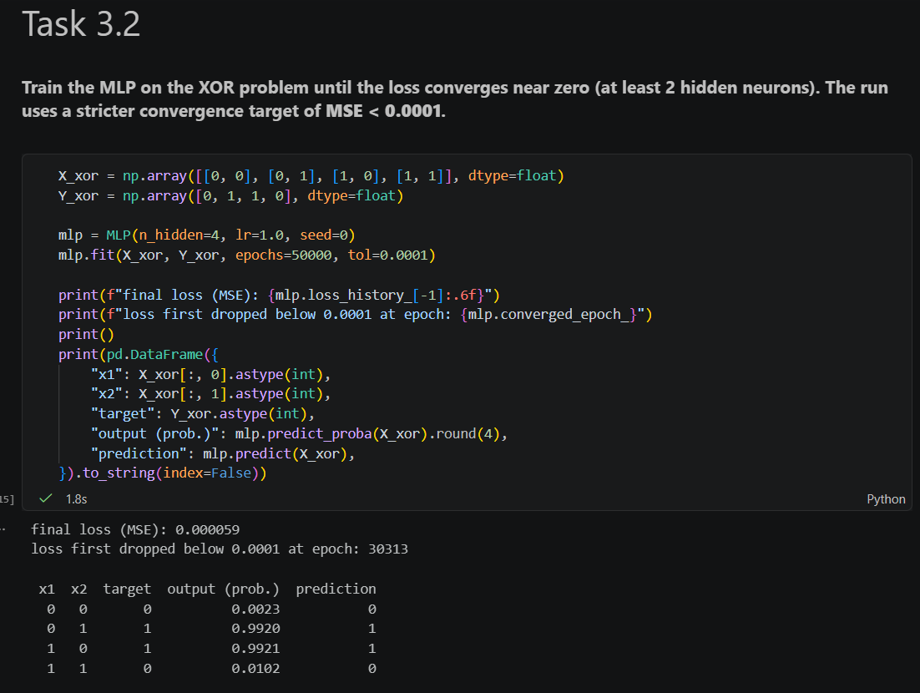
Task 3.3
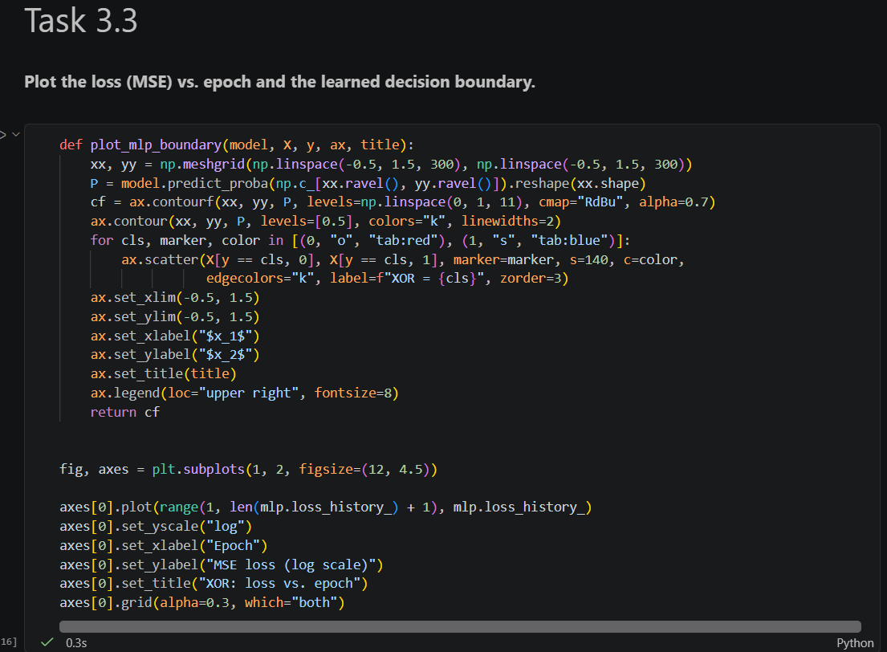

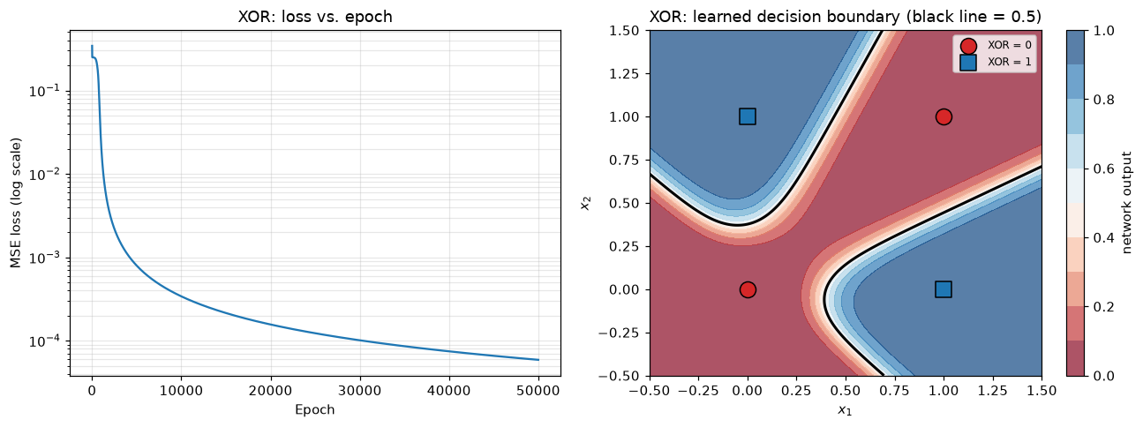
Task 3.4
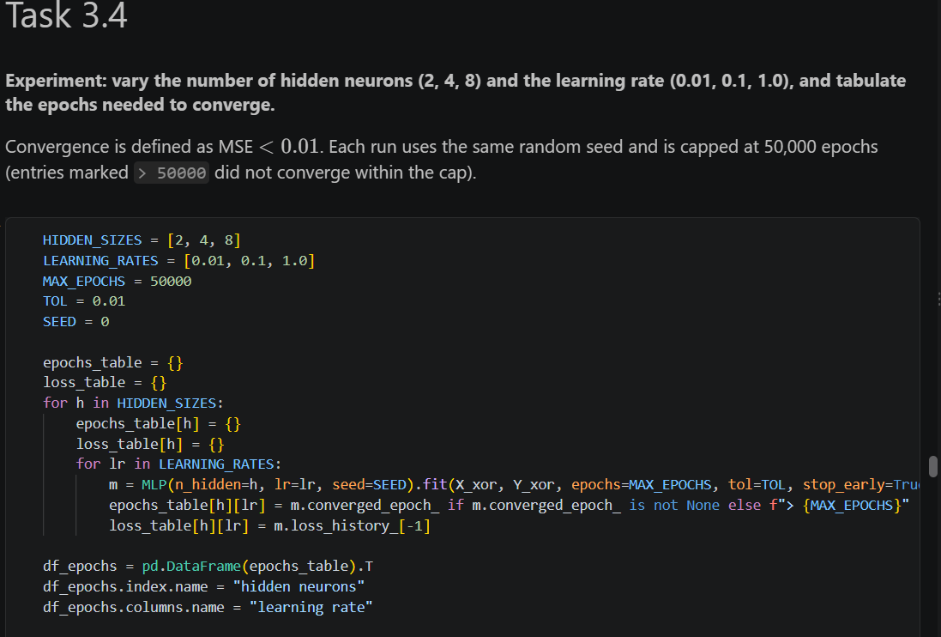
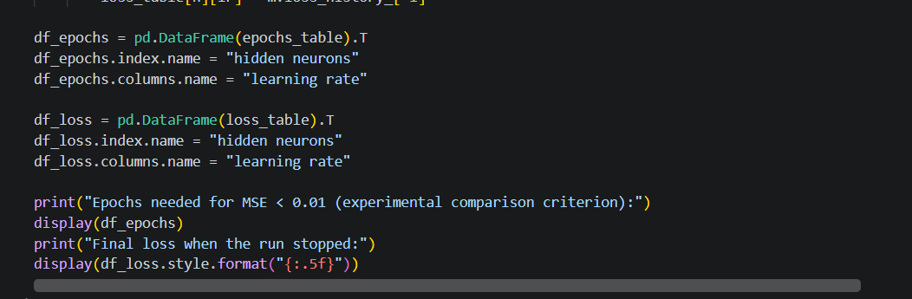

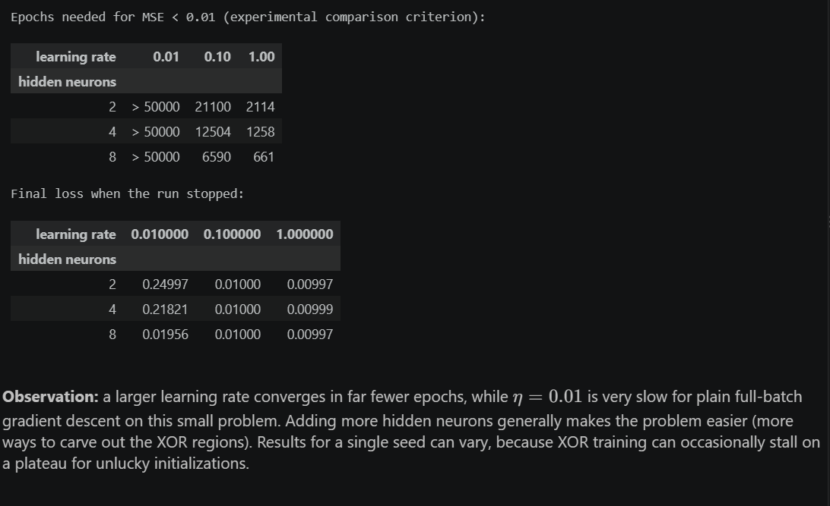

Task 04
Task 4.1
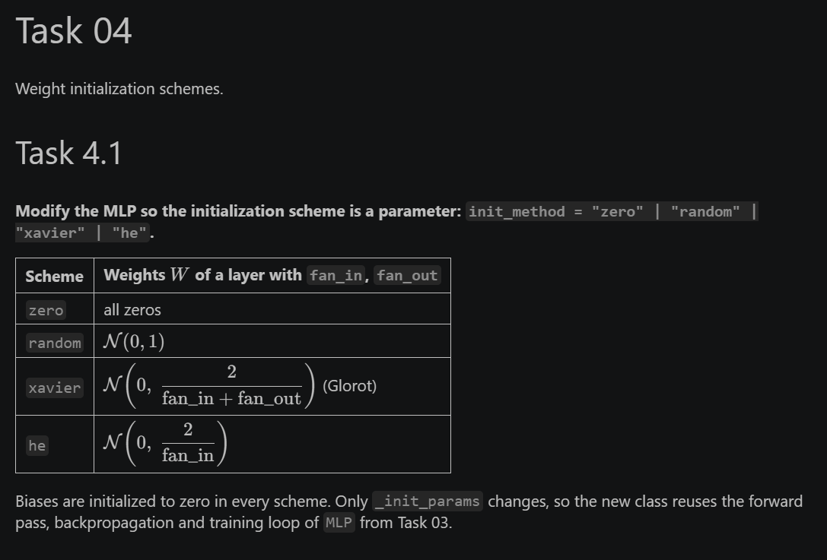
class MLPInit(MLP):
def __init__(self, n_in=2, n_hidden=2, n_out=1, lr=0.5, seed=0, init_method="random"):
assert init_method in ("zero", "random", "xavier", "he"), init_method
self.init_method = init_method # must be set before the parent calls _init_params
super().__init__(n_in, n_hidden, n_out, lr, seed)

def _weights(self, fan_in, fan_out):
if self.init_method == "zero":
return np.zeros((fan_in, fan_out))
if self.init_method == "random":
return self.rng.standard_normal((fan_in, fan_out))
if self.init_method == "xavier":
return self.rng.standard_normal((fan_in, fan_out)) * np.sqrt(2.0 / (fan_in + fan_out))
if self.init_method == "he":
return self.rng.standard_normal((fan_in, fan_out)) * np.sqrt(2.0 / fan_in)

def _init_params(self):
self.W1 = self._weights(self.n_in, self.n_hidden)
self.b1 = np.zeros((1, self.n_hidden))
self.W2 = self._weights(self.n_hidden, self.n_out)
self.b2 = np.zeros((1, self.n_out))

Task 4.2
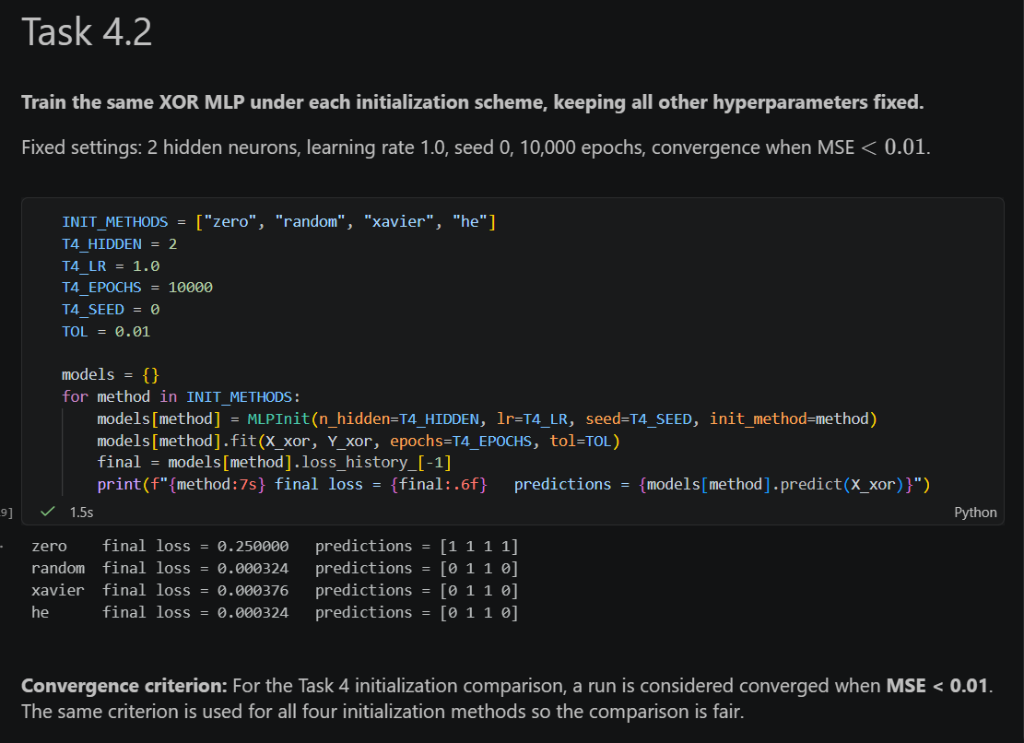

Task 4.3
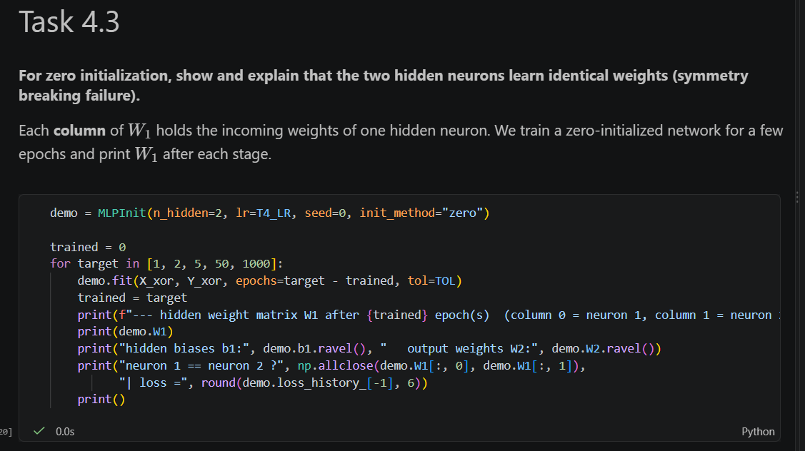
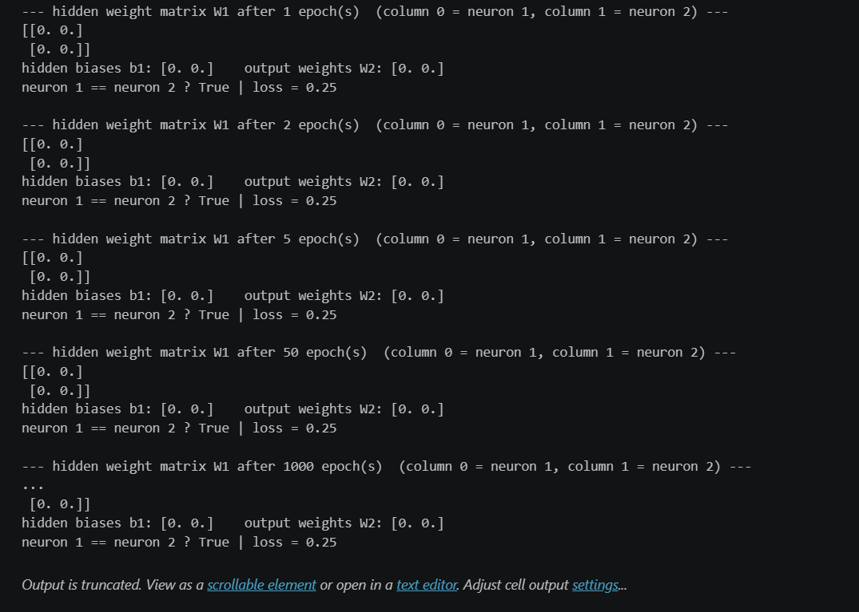
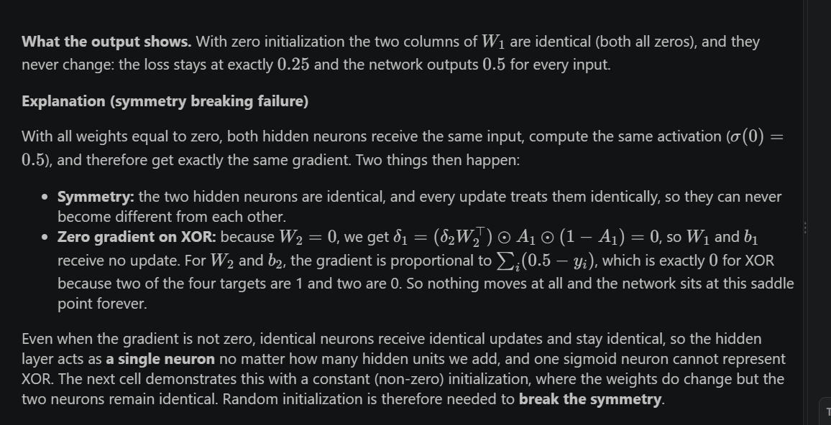
# Supplementary demo: identical NON-zero start (every weight = 0.5), so gradients are non-zero
sym = MLPInit(n_hidden=2, lr=T4_LR, seed=0, init_method="zero")
sym.W1[:] = 0.5
sym.W2[:] = 0.5

trained = 0
for target in [1, 5, 100, 2000]:
sym.fit(X_xor, Y_xor, epochs=target - trained, tol=TOL)
trained = target
print(f"--- W1 after {trained} epoch(s) (column 0 = neuron 1, column 1 = neuron 2) ---")
print(sym.W1)
print("neuron 1 == neuron 2 ?", np.allclose(sym.W1[:, 0], sym.W1[:, 1]),
"| loss =", round(sym.loss_history_[-1], 6))
print()

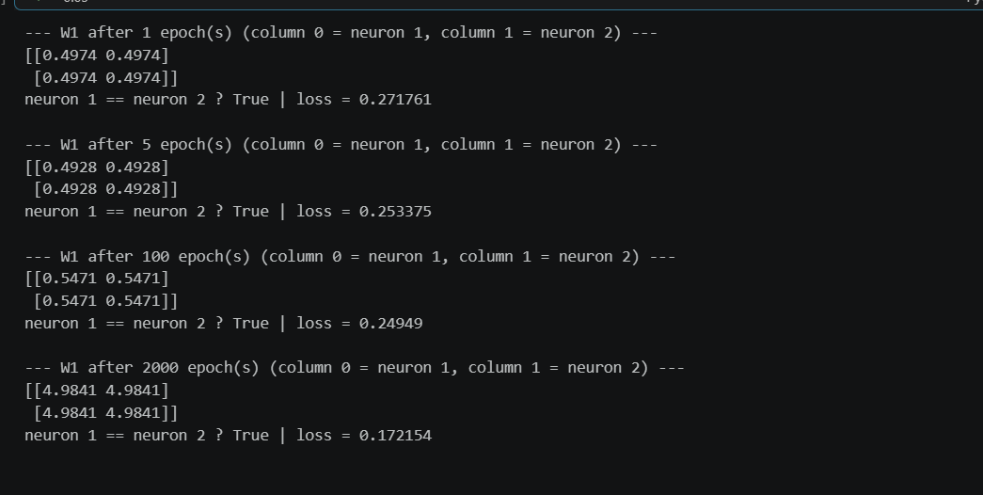

Task 4.4
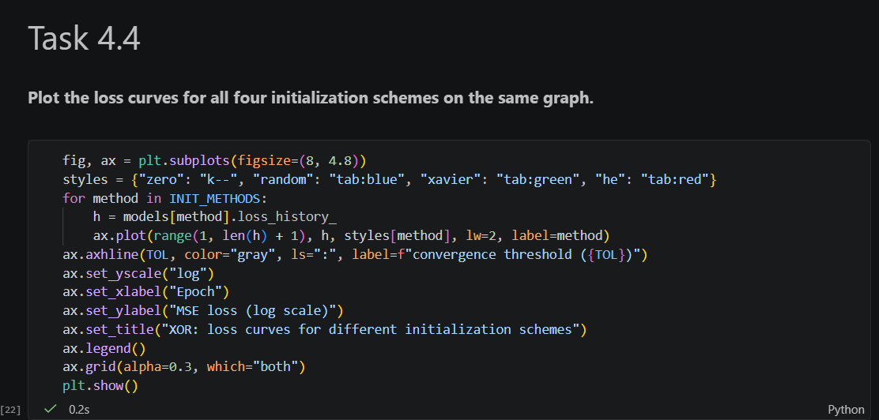

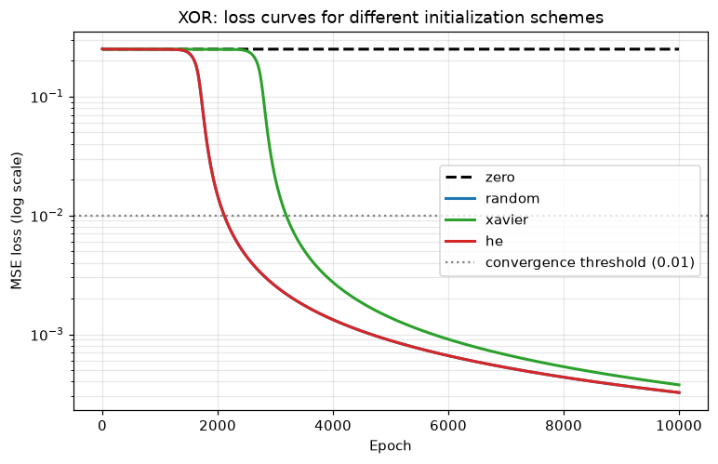

Task 4.5

rows = []
for method in INIT_METHODS:
m = models[method]
rows.append({
"init_method": method,
"epochs to converge (loss < 0.01)": m.converged_epoch_ if m.converged_epoch_ is not None else f"not converged in {T4_EPOCHS}",
f"final loss after {T4_EPOCHS} epochs": round(m.loss_history_[-1], 6),
})
print("Single run (seed 0):")
display(pd.DataFrame(rows).set_index("init_method"))

N_SEEDS = 10
rows = []
for method in INIT_METHODS:
conv, final_losses = [], []
for s in range(N_SEEDS):
m = MLPInit(n_hidden=T4_HIDDEN, lr=T4_LR, seed=s, init_method=method)
m.fit(X_xor, Y_xor, epochs=T4_EPOCHS, tol=TOL)
final_losses.append(m.loss_history_[-1])
if m.converged_epoch_ is not None:
conv.append(m.converged_epoch_)
rows.append({
"init_method": method,
f"converged runs (of {N_SEEDS})": len(conv),
"median epochs (converged runs)": int(np.median(conv)) if conv else "-",
"mean final loss": round(float(np.mean(final_losses)), 5),
})
print(f"Robustness over {N_SEEDS} seeds:")
display(pd.DataFrame(rows).set_index("init_method"))

